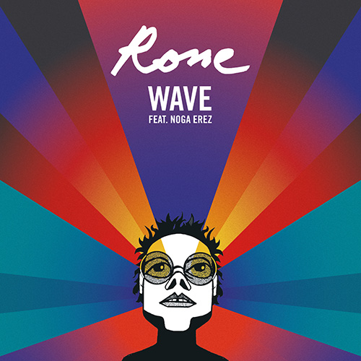
RONE
WAVE EP

Cat N° : iF3063
Release date : 01.06.2018

Artwork by Michel Gondry

- Wave (Sorg Radio Version) – 3’32
- Wave (Locked Groove Remix) – 6’49
- Wave (Negative Gemini Remix) – 3:53
- Wave (Video version) – 3:56

Rone continues to take us on a tour of his radiant citadel "Mirapolis.” This time guided alongside his synthesisers, by the voice of Noga Erez, the Tel Aviv writer performer on “Wave" on three different remix paths.

The Remix by Parisian beatmaker Sorg (stage and studio partner of Cincinnati-based rapper/beatboxer: Napoleon Maddox), "Wave" is carried away in a storm of bleeps, loops and distortions. Locked Groove, who’s are leaders (alongside Tales of Us and Scuba) of their melodic but pacy techno scene, inject a hypnotic and sedative serum into the original, particularly adapted to the expectations of the dancefloor surfers. Brooklyn producer Negative Gemini, spotted in the Anglo-Saxon blogosphere, following the release of her fascinating EP "Bad Baby" on 100% Electronica, creates an ambient re-reading in the modern sense. Both ethereal and dynamic, breaking the surface you find your arms in the air and head in the stars.

In conclusion, we find “Wave” original version, edited especially for Rone’s new clip, realized by the “mad” swiss Greg Barth, which will be released on May 17th on Apple Music, and May 30th on YouTube.

About Greg Barth: Greg Barth is an award-winning artist and director from Geneva, Switzerland, currently based in London. He specialises in design driven projects using physical effects, ranging from video art and installations to performance and short films. His passion for strong, often surreal concepts, and contemporary minimal aesthetics have brought him to work for renown international clients, get published in prestigious design books, and be strongly featured in the visual industry’s leading blogs and websites.
Rone on tour: Today, Rone plays everywhere in the world during the Mirapolis Tour, among which gigs in Canada, in Scandinavia during the French Express Tour (Sweden, Norway and Denmark), in Europe (Turkey, Germany, Belgium, Spain, Italy), in the prestigious Montreux Jazz Festival in Switzerland, of course in France, headlining several festivals (Printemps de Bourges, Nuits Sonores, Musilac, Vieilles Charrues…) and in the Paris Zenith planned for June 15th.

