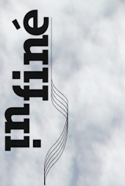
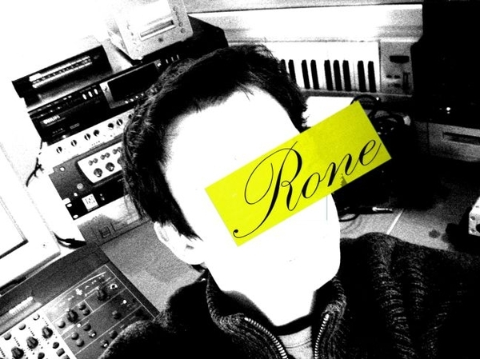


« aiR-Force-One ! »
Praised by the likes of Ellen Alien, Laurent Garnier, Masaya or Wagon Repair, Erwan Castex aka Rone, just after an amazing feat for the label Curle, is already emerging as one of the new Pilots of the airy, minimal techno scene.
Gliding alongside Border Community's and Dial's producers, this young Parisian is voluntarily venturing between the celestial territories of electronica, the psychedelic spells of sunshine of ‘Shoegazing’ or the tormented drafts of Motor City. Fasten your safety belt and sit down comfortably for this new EP signed by InFiné!
Sweet take-off with «Bora», an angelic soaring of synthetic waves, blown away by progressive and hypnotic rhythms towards imaginary and sacred horizons. This divine celebration is barely disordered by the revolutionary lyricism puffed onto the vocal version (recently used on Agoria's « At The Controls » compilation) by a young and successful French Science Fiction writer.
Half-way through the flight, boisterous beats harry the heavenly organ chords of «Flesh» for the listener’s greatest enjoyment. Last air trick, uplifting and soothing at the same time, «Spanish Breakfast» concludes a supersonic EP, that makes one wish one never had to touch down.
Music Bless you !

Contact Promo: Julien Gagnebien (+49 30 37 00 55 19)
julien@infine-music.com

updates & information on :
www.myspace.com/Rone
www.infine-music.com
1- Bora Instru
2- Flesh
3- Spanish Breakfast
4- Bora Vocal

