DEENA ABDELWAHED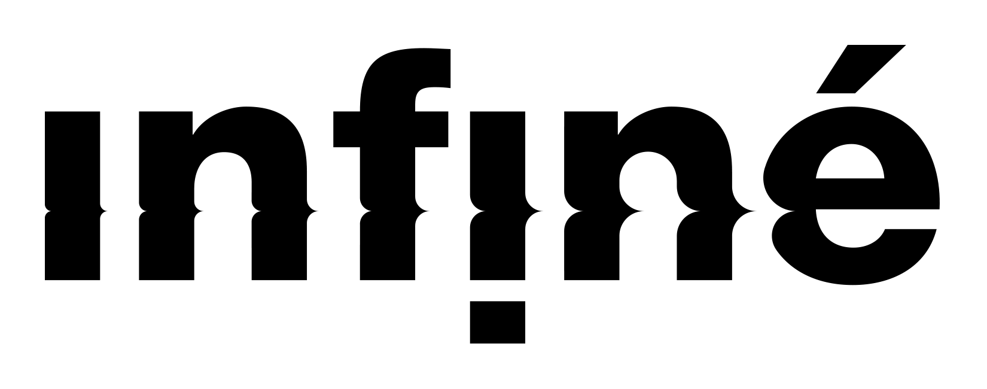

Khonnar Remixes

IF2076

Release 24.05.2019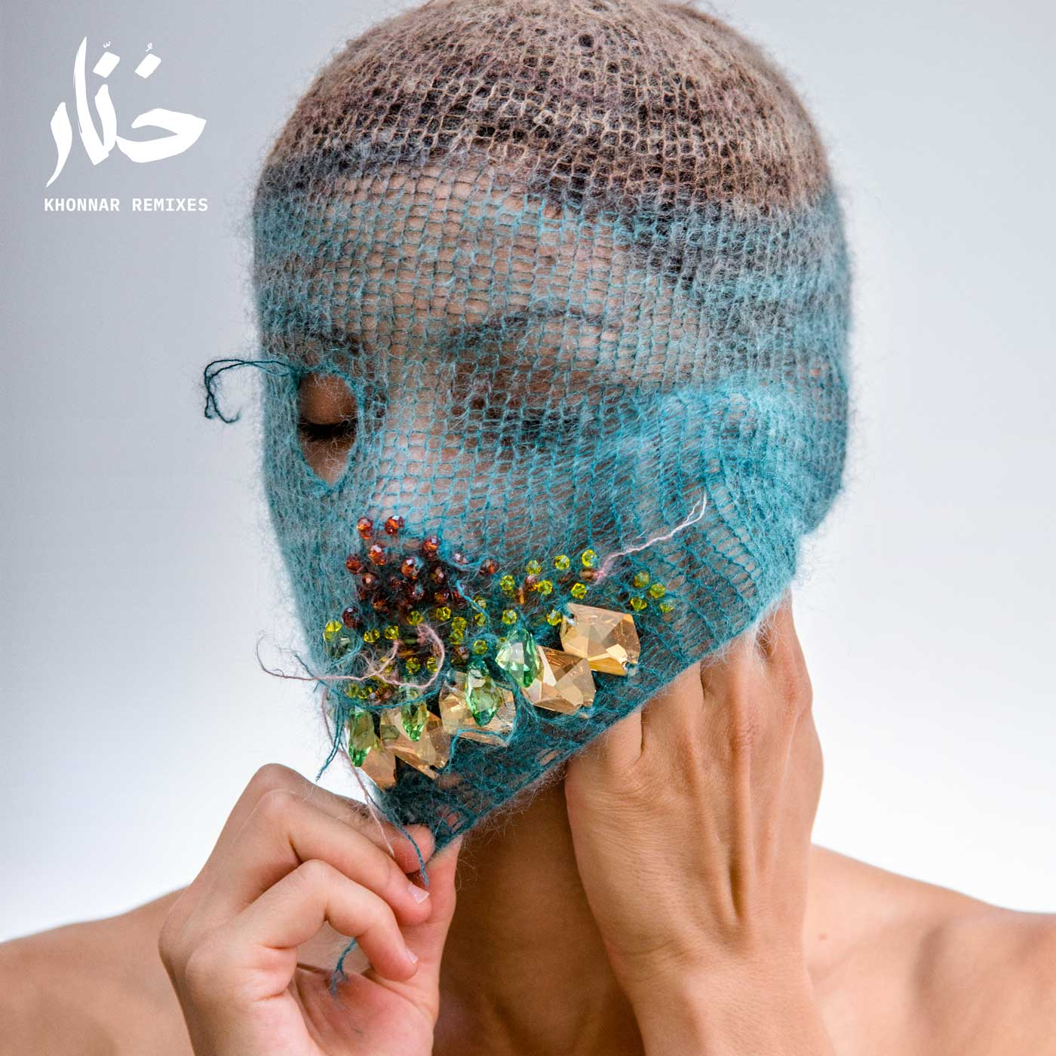

TRACKLISTING:

*VINYL*

A1 - Deena Abdelwahed - Tawa (M.E.S.H. Remix) 05:35

A2 - Deena Abdelwahed - Ken Skett (Karen Gwyer Remix) 07:33

B1 - Deena Abdelwahed - Ababab (Ital Tek Remix) 04:34

B2 - Deena Abdelwahed - 5/5 (Lord Of The Isle Remix)  06:50

*DIGITAL*

1 - Deena Abdelwahed - Ababab (Ital Tek Remix)

2 - Deena Abdelwahed - 5/5 (Lord Of The Isle Remix)

3 - Deena Abdelwahed - Rabbouni (Enyang Ha Remix)

4 - Deena Abdelwahed - Fdhiha (Dawan remix)

Masks and photos by Judas Companion

Design by Motoplastic

Emerging artists rarely make a big splash with a complete album right out of the box, but that was not counting on Deena Abdelwahed.

While the young artist of Tunisian origin stood out with her daring DJ sets, it is her surprising first album, "Khonnar", released at the end of 2018 on InFine which sealed her status of producer, guaranteeing her a place in several tops end of years such as Resident Advisor, Trax, Tsugi, The Quietus and Vinyl Factory.

It was an assumed choice not to release single so that the album is above all listened to as a whole, like a kind of podcast ranging from ambient, bass, techno to Arabic influences and songs. As she begins to present her "compositions" in a live set, it is normal for the songs in the album to start having their own lives, in different forms.

Now comes "Khonnar Remixes", 4 pieces perfectly linked recreating alone a true autonomous entity.

Firstly, it's the turn of M.E.S.H (aka James Whipple), already known for his unconventional club productions on the Pan label, to add his music inspired by propulsive and frenetic rhythms of avant-garde bass music. The American producer, Karen Gwyer, who recently showed up with her excellent album Rembo, brings a touch of techno warpienne to the piece, infusing it with a rather disturbing atmosphere which, towards the end, develops into a wonderful electronic ballad.

Lord of the Isles: DJ, producer and musician.

Dawan, from the northern tip of Tunisia, Hamza Nasraoui AKA Dawan began his career as SixHon playing deep house and techno.

By migrating to denser tones, he draws his inspiration from soft and dark melodies, Dawan was introduced to the future garage (Burial, Four Tet). Beginning of 2015, he participated in the Laboratory of Hearing, Helsinki. The musical projects of Dawan are of a remarkable musical variety.

Enyang Ha chose sound as a way of communicating with the world. His music exists as a language independent of origin, time or space. His moving productions and live performances reflect these possibilities and tell stories to the public.

Ital Tek is the stage name of Alan Myson, an electronic music composer from Brighton. As an Italian Tek, he has released six albums on the Planet Mu label.

Myson started playing as Ital Tek in 2006, recording for the Net Lab label. The first release of Ital Tek for Planet Mu was a 12 "single released in 2007, followed by the album Cyclical in 2008. Its release in 2016, Hollowed, has been described by Clash Music as" intelligent dubstep « .

In short "Khonnar Remixes" plunges us into the techno revolt already known on « Khonnar".