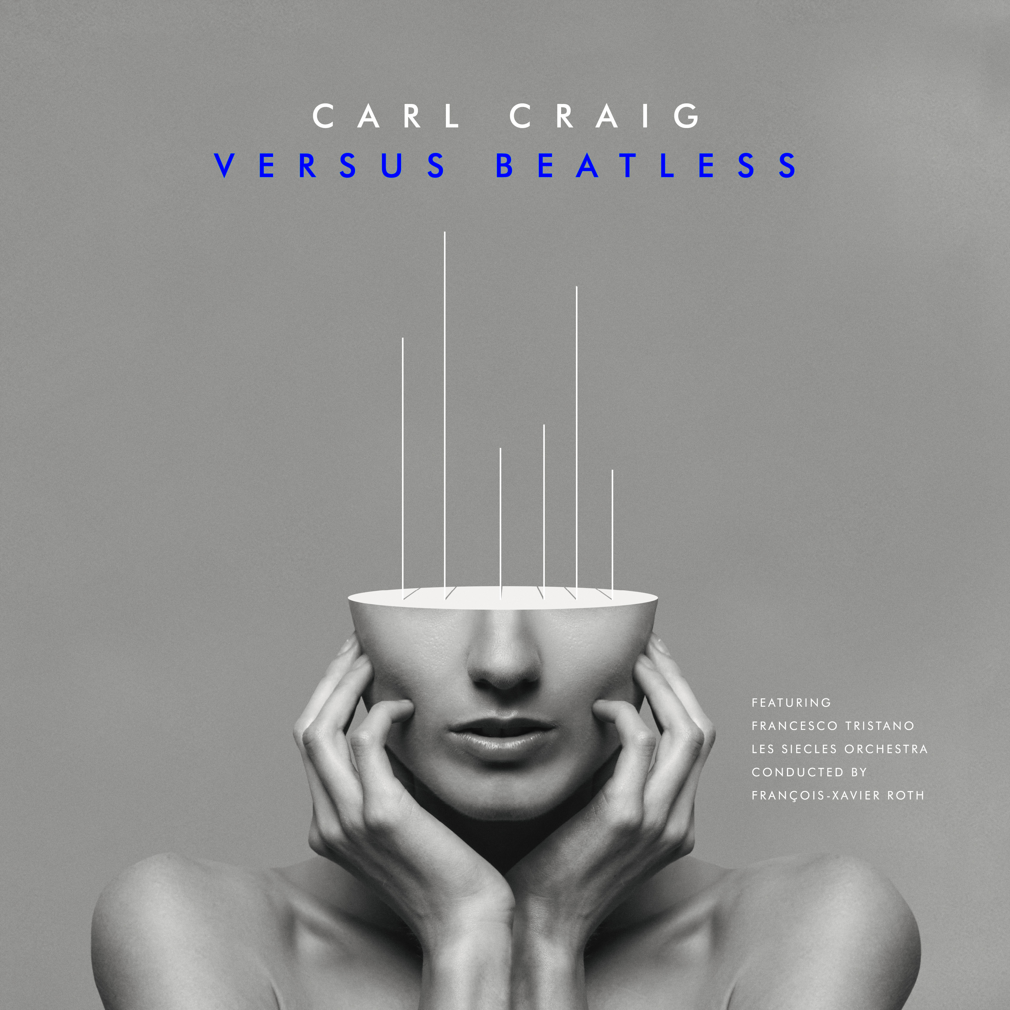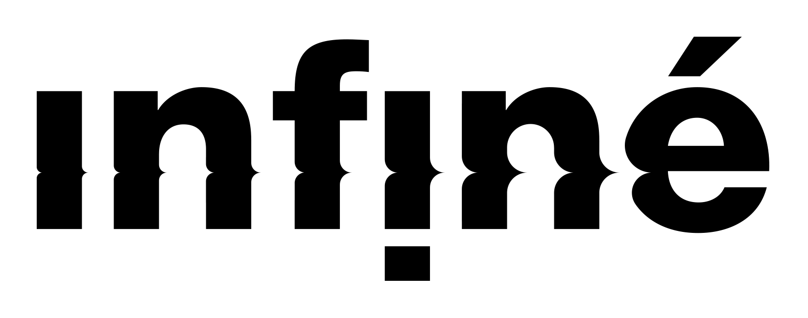

CARL CRAIG

VERSUS BEATLESS

featuring. Francesco Tristano, Les Siècles Orchestra

Conducted by François-Xavier Roth

RELEASE DATE - APRIL 24th, 2019

**Sortie Digitale**

From techno to to electronic cross-over classical, and now back again – Carl Craig's Versus project continues to morph and evolve with the release of five beatless versions taken from the eponymous album. On the eve of the Carl Craig concert with the Chinake! Orchestra at the Royal Albert Hall (which promises to be mythical) InFiné partners with Planet E for the release of 5 exclusive, purely orchestral, versions.

This Versus Beatless EP brings together the classical musical base used in the making of Versus (2017). These pieces "without electronics" give primacy to the orchestral texture of the instruments and to Carl Craig's close work with Les Siècles during the recording sessions at Davoux studio. With this new take on 5 Planet E catalogue classics, Carl Craig and Francesco Tristano transport their listeners into a new time space. Techno is entering concert halls. The European musical tradition pays tribute to the city of Detroit.